|  |  |  |
| --- | --- | --- |
|  |  |  |

|  |  |  |
| --- | --- | --- |
|  |  |  |

|  |  |  |
| --- | --- | --- |
|  |  |  |

|  |  |  |  |
| --- | --- | --- | --- |
|  |  |  |  |

|  |  |  |  |
| --- | --- | --- | --- |
|  |  |  |  |

<https://pxhere.com/fr/photo/591626>

|  |  |  |
| --- | --- | --- |
|  |  |  |

Motifs d’après: publicdomainpictures.net

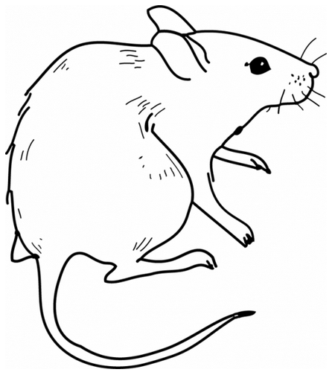   

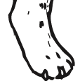 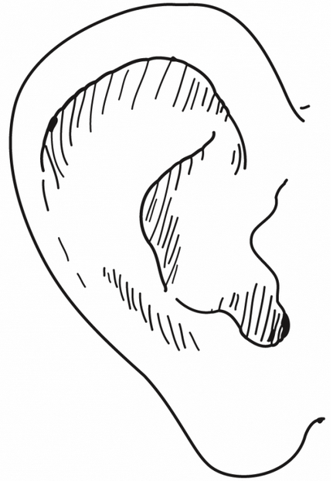 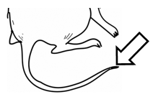 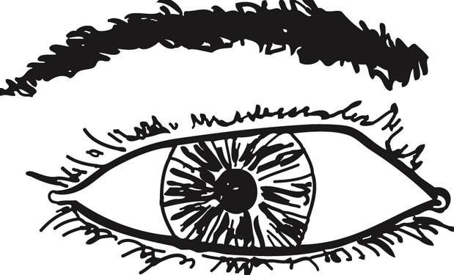

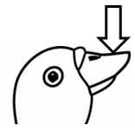 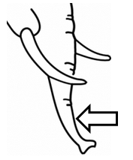

Dessins d’après: <http://www.cndp.fr/crdp-dijon/-Clic-images-.html>